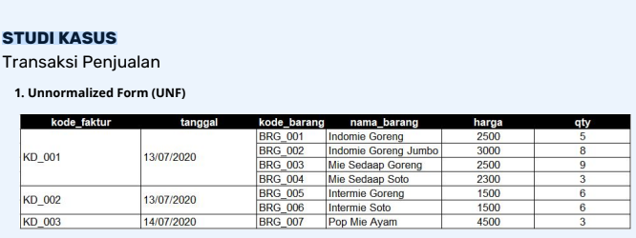

|  |  |  |  |  |  |
| --- | --- | --- | --- | --- | --- |
| Kode_Faktur | Tanggal | Kode_Barang | Nama_Barang | Harga | Qty |
| KD_001 | 13/07/2020 | BRG_0001 | Indomie Goreng | 2500 | 5 |
| KD_001 | 13/07/2020 | BRG_0002 | Indomie Goreng Jumbo | 3000 | 8 |
| KD_001 | 13/07/2020 | BRG_0003 | Mie Sedaap Soto | 2500 | 9 |
| KD_001 | 13/07/2020 | BRG_0004 | Mie Sedaap Soto | 2300 | 3 |
| KD_002 | 13/07/2020 | BRG_0005 | Intermie Goreng | 1500 | 6 |
| KD_002 | 13/07/2020 | BRG_0006 | Intermie Soto | 1500 | 6 |
| KD_003 | 13/07/2020 | BRG_0007 | Pop Mie Ayam | 4500 | 3 |

1. **Second Normal Form**

**Tabel Faktur**

|  |  |  |  |
| --- | --- | --- | --- |
| Kode_Faktur | Tanggal | Kode_Barang | Qty |
| KD_001 | 13/07/2020 | BRG_0001 | 5 |
| KD_001 | 13/07/2020 | BRG_0002 | 8 |
| KD_001 | 13/07/2020 | BRG_0003 | 9 |
| KD_001 | 13/07/2020 | BRG_0004 | 3 |
| KD_002 | 13/07/2020 | BRG_0005 | 6 |
| KD_002 | 13/07/2020 | BRG_0006 | 6 |
| KD_003 | 13/07/2020 | BRG_0007 | 3 |

**Tabel Barang**

|  |  |  |
| --- | --- | --- |
| Kode_Barang | Nama_Barang | Harga |
| BRG_0001 | Indomie Goreng | 2500 |
| BRG_0002 | Indomie Goreng Jumbo | 3000 |
| BRG_0003 | Mie Sedaap Soto | 2500 |
| BRG_0004 | Mie Sedaap Soto | 2300 |
| BRG_0005 | Intermie Goreng | 1500 |
| BRG_0006 | Intermie Soto | 1500 |
| BRG_0007 | Pop Mie Ayam | 4500 |

1. **Third Normal Form (3NF)**

**Tabel Faktur**

|  |  |
| --- | --- |
| Kode Faktur | Tanggal |
| KD_001 | 13/07/2020 |
| KD_002 | 13/07/2020 |
| KD_003 | 14/07/2020 |

**Tabel Barang**

|  |  |  |
| --- | --- | --- |
| Kode Barang | Nama Barang | Harga |
| BRG_0001 | Indomie Goreng | 2500 |
| BRG_0002 | Indomie Goreng Jumbo | 3000 |
| BRG_0003 | Mie Sedaap Soto | 2500 |
| BRG_0004 | Mie Sedaap Soto | 2300 |
| BRG_0005 | Intermie Goreng | 1500 |
| BRG_0006 | Intermie Soto | 1500 |
| BRG_0007 | Pop Mie Ayam | 4500 |

**Tabel Data Faktur Transaksi**

|  |  |  |
| --- | --- | --- |
| Kode_Faktur | Kode_Barang | Qty |
| KD_001 | BRG_0001 | 5 |
| KD_001 | BRG_0002 | 8 |
| KD_001 | BRG_0003 | 9 |
| KD_001 | BRG_0004 | 3 |
| KD_002 | BRG_0005 | 6 |
| KD_002 | BRG_0006 | 6 |
| KD_003 | BRG_0007 | 3 |

**Design Database**

Tbl_faktur

Kode_faktur(Varchar(20) Primary Key):

Tanggal Date

Tbl_barang

Kode_barang(Varchar(20) Primary Key);

Nama_barang(Varchar(50);

Harga(int)

Tbl_DetailTransaksi

Kode_faktur(Varchar(20)Foreign Key);

Kode_barang (Varchar(20)Foreign Key);

Qty int;

1

1

1